Please print clearly and complete all information
Date:_____________
Name:________________________________________________ Birth Date:______/_____/________
Address:_______________________________ City:___________________ State:______ Zip:_________
Phone: (____)_________________ Work: (____)__________________Cell: (___)___________________
E-mail Address:_______________________________@_____________
Circle one: Married Partnered Single

Employer:_________________________________ Occupation:_________________________________
Address:___________________________________City:_________________________ State:_________
Please circle how you heard about our business.
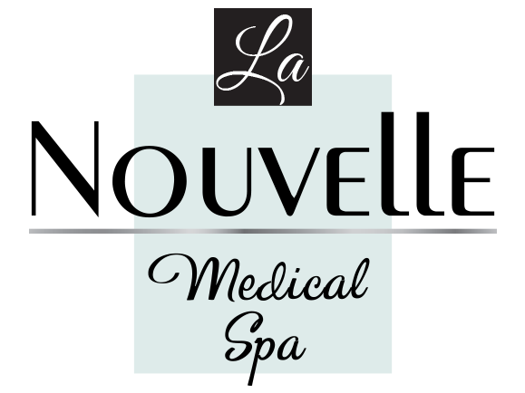
Referred By: Radio Internet Yelp Friend:_________________________________
Please fill out the form and email to lanouvellespa@yahoo.com
Patient Information Form
La Nouvelle Medical Spa
Medical Director: Antoine Hanna, M.D.
1700 N Rose Ave #230, Oxnard, CA 93030
(805) 988-2638
Emergency Contact:___________________________ Phone: (___)____________________________
Relationship:________________________________
Notice to consumers: Medical doctors are licensed and regulated by the Medical Board of California. (800) 633-2322.

I hereby acknowledge that all facts related to Dr. Hanna are true. I am aware that I have access to my medical records per HIPPA laws. I am aware that my records are confidential. I am aware that I have the right to my privacy. I am aware that my records cannot be shared with 3rd parties without my permission, including my friends and family members.

Patient Signature________________________________________ Date:_____________________

Do you have ADVANCE DIRECTIVE? ______YES _____NO

